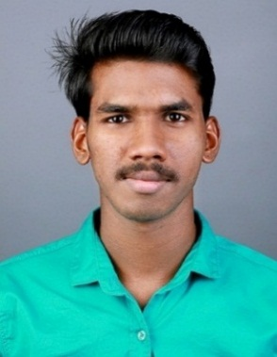
TOGY .A. TONY

Email : togyatony@gmail.com

(M) : +91-8281659156

+91-9526924815
Address: S/o TONY A.V
ANATHAZHATH HOUSE, MAHATHMA ROAD 2nd STREET,
CHIYYARAM P.O, THRISSUR, KERALA – 680026

Career Objective
To achieve high career growth through a continuous learning process and keep myself dynamic, visionary and competitive with the changing scenario of the world. To live honest, create value and recognition on work place by producing the best result for the organization.

Work Experience

Flora natural flavours and extracts Pvt. Ltd. Thrissur, Kerala
Designation : Research Associate
Department : QA/QC
Duration : 17th june 2019 – 30th Nov 2020.
Roles and Responsibilities
    - Analysis of raw material, in process and final product sample (both physical and
chemical)
    - Handling instruments like HPLC , GAS CHROMATOGRAPHY , UV visible
SPECTROPHOTOMETER, pH METER
    - Online inspections in the production and packing areas

Academic profile

QUALIFICATION | INSTITUTION | BOARD / UNIVERSITY | YEAR OF PASSING | AGGREGATE (%)
Bachelors of science in Chemistry  (Bsc.Chemistry) | Sahrdaya college of advanced studies ,Kodakara, Thrissur | University of Calicut | 2019 | 62.6%
PLUS TWO | St.Thomas.H.S.S, Thope, Thrissur | HSE Kerala | 2015 | 72.6%
SSLC | Holy Angels’s school, Thrissur | Kerala State Board | 2013 | 80%

Personal skills
- Good oral, written & presentation skills.
- A high tolerance of stress and enjoys responsibilities.
- Quick learner with good grasping ability, Self- motivated and optimistic.
- Action-oriented and result-focused, lead & work as a team in an organized way.

Academic project
A comparative study of “Dasamoolahareethaki lehyam” (Ayurvedic product) from three different companies based on physico-chemical parameters at CARE KERALAM Ltd, KINFRA Park, Koratty, Thrissur, Kerala.

Co-curricular Activities
- Participated in entrepreneurship awareness camp conducted by KITCO Ltd.
- Participated in one day seminar on topic NANO Chemistry.

Personal Details
Date of birth : 11-02-1997
Linguistic Ability : English, Malayalam
Nationality : Indian
Hobbies & Interests : Photography, Editing
Marital status : Single
Reference
Mrs. Jismi Dixon
QA Executive
Flora natural flavours and extracts pvt ltd, Thrissur, Kerala
Phone : +919846926470
Mail : mailtojismi@gmail.com
Declaration
I solemnly declare that the statements made by me are true to the best of my knowledge and belief.
Date : 12-01-2021
Place: Thrissur (Togy .A. Tony)

