**Navin Ramadas**

Operations Manager

**Address:**

Ramvila’S,

Kaikulangara, Kollam,

Kerala, India.

Pin: 691013

**Phone**:

+91 9539 896659 (IND)

+971 50 1414 236 (UAE)

**E-mail:**

[navin.ramadas@gmail.com](mailto:navin.ramadas@gmail.com)

[navinsree@yahoo.com](mailto:navinsree@yahoo.com)

**Skype:**

navin.ram21

**WhatsApp:**

+971 50 1414 236

Organizational

Decision Making

Leadership

Time Management

Adaptable

Teamwork

Analytical

Creativity

Quick Learner

Flexible

Windows

Linux

Mac

Microsoft Office

Auto CAD

Tally

English

Malayalam

Hindi

Tamil

In-depth exposure in an Operations, Technical Support, Sales & Marketing, Procurement, Manufacturing Project Implement & Quality Assurance of over 18 years experience (including 12 years in the Gulf) in Plastics Engineering Industry specializing in Geo Synthetic, Flexible Packaging and Injection Molding Products. And good knowledge with Plastics Materials, Production Activity, Mould Design & Mould Making, Processing, Testing, ISO Audit Laws and New Product Development.

**Career Profile**

**Operations – Projects (Plastics)**

**CLARITY AQUA SYSTEMS (P) LTD - KOCHI, KERALA, INDIA**

* Coordinate internal resources and third parties/vendors for the flawless execution of projects.
* Ensure that all projects are delivered on-time, within scope and within budget.
* Ensure resource availability and allocation.
* Develop a detailed project plan to monitor and track progress.
* Measure project performance using appropriate tools and techniques.
* Report and escalate to management as needed.
* Establish and maintain relationships with third parties/vendors.
* Create and maintain comprehensive project documentation.
* Perform other related duties as assigned.

**Achievement:**

* + Geo Synthetic products (HDPE Liner) installation on water body land.

**Operations Manager**

**PLAS TECH GLOBAL PLASTIC TRADING LLC – DUBAI, UAE**

* + Provide inspired leadership for the organization.
  + Make important and review operational policies and procedures.
  + Develop, implement and review operational policies and procedures.
  + Assist HR with recruiting when necessary.
  + Oversee budgeting, reporting, planning, and auditing.
  + Work with senior stakeholders.
  + Work with the board of directors to determine values and mission, and plan for short and long-term goals.
  + Identity worker communication with the management team.
  + Build alliances and partnerships with other organizations.
  + Support worker communication with the management team.

**Achievement:**

* + Develop the market share including Middle East, Africa & India.
  + Introduced the Geo Synthetic products supply & installation.

**Technical Support Manger**

**SINAK PLASTO INTERNATIONAL Co LLC – DUBAI, UAE**

* Manage a support team to provide first class post sales support.
* Provide input into the pre sales process and act as a lead on support and service issues.
* Set objectives, evaluate progress and instil a high performance culture with focus on team work, service excellence for resolving customer issues.
* Set-up, manage and improve standards and procedures within the team.
* Ensure working practices are well defined and operational.
* Manage the team and individual performance, technical and skills development.
* Remain aware of new product developments.

**Achievement:**

* Develop the market share including Middle East & Africa.
* Introduced new products and increase the profit ratio.
* Develop the new specification for products.

**Q A Engineer cum Geo M - Production & QC/QA**

**KANGAROO PLASTICS ME LLC.- DUBAI, UAE**

* Review the work orders, prepare Production Plan and schedule for Geo M Liner, Green House Film, Master Batch and Geo M Welding Rod Production.
* Technical Support to Sales & Marketing Team.
* Performing in-process inspections while production of Geo M & F P.
* Testing & controlling of the products in the process as well as the finished

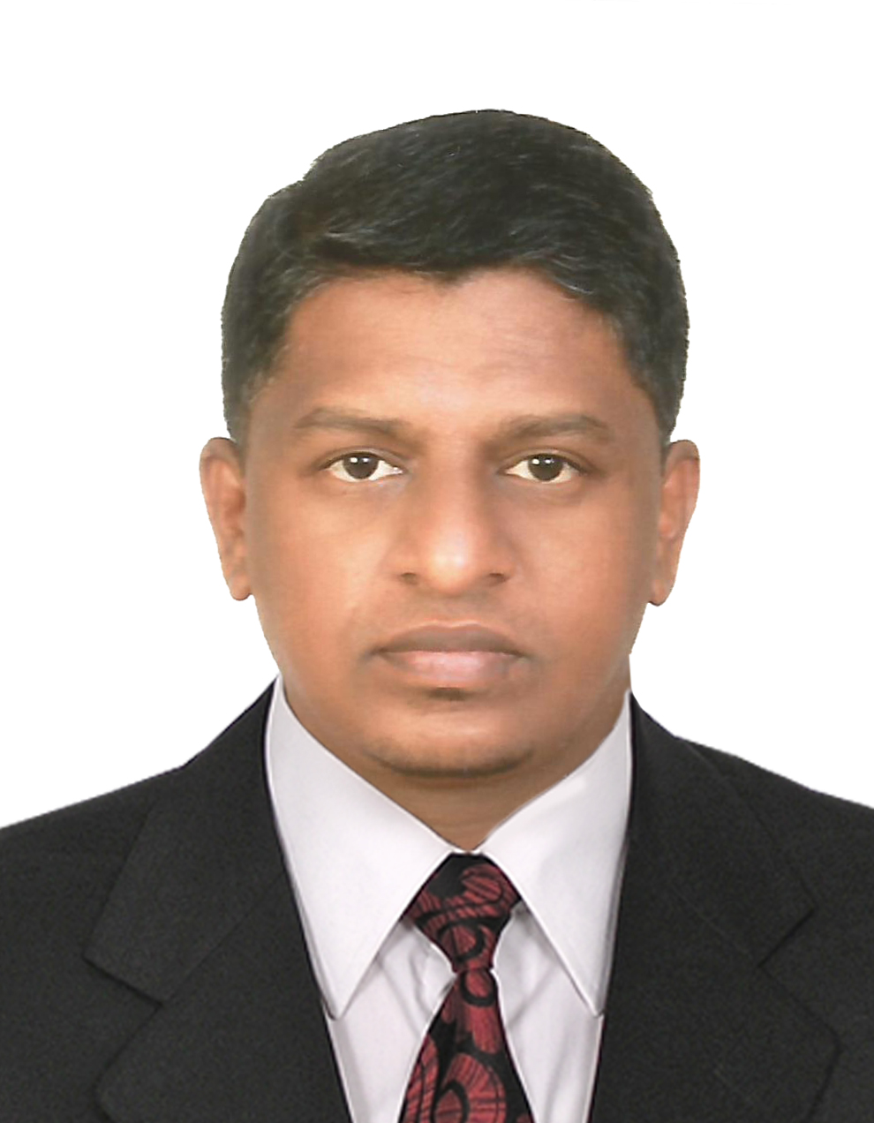

**2018-05**

**To**

**2019-08**

**Personal Info**

**2014-09**

**To**

**2018-04**

**Skills**

**2012-12**

**To**

**2014-08**

**Software**

**Languages**

**2007-01**

**To**

**2012-11**

**Navin Ramadas**

Operations Manager

**Address:**

Ramvila’S,

Kaikulangara, Kollam,

Kerala, India.

**Phone**:

+91 9539 896659 (IND)

+971 50 1414 236 (UAE)

**E-mail:**

[navin.ramadas@gmail.com](mailto:navin.ramadas@gmail.com)

[navinsree@yahoo.com](mailto:navinsree@yahoo.com)

**Skype:**

navin.ram21

**WhatsApp:**

+971 50 1414 236

Organizational

Decision Making

Leadership

Time Management

Adaptable

Teamwork

Analytical

Creativity

Quick Learner

Flexible

Windows

Linux

Mac

Microsoft Office

Auto CAD

Tally

English

Malayalam

Hindi

Tamil

products of Geo M & F P.

* Monitoring process parameters and their effect on the products and advising and informed to the operators / section / production supervisors.
* Recommending corrective and preventive action and ensure that the appropriate actions are taken by the production personnel
* Monitoring and verifying the performance of the trail samples of the new raw materials.
* Report to QA Supervisor / Manager about any variations in the process of raw materials and machine conditions, which affecting the product quality.
* Calibrate the testing equipment in Quality Lab and mechanical balances in the plant.
* Authorized to release the finished products, and oversee internal ISO auditing.
* Performing testing equipments with ASTM, BS & DIN standard.

**Projects**

* Erected & performing Production for Geo M - HDPE / LLDPE / PP Liners & Green House Film with New Single Screw Three Layers Cox – Extrusion M/c.
* New Geo M QC/QA Lab Structure & Erected of New Testing Instrument & performing test with Geo M ASTM Std.
* New Twin Screw Extrude Machine for Master Batch & Welding Rod (Extrusion) & Resin Blender.
* Single Screw Flat Die Type Extrusion for Sheet Extrusion (Cable Protection Sheet / Tape / Tile).

**Production In-charge**

**TELE TECH CORPORATION, (M/S CREATIVE POLYMERS), KOLLAM, KERALA, INDIA**

* Review the work orders, prepare Production Plan and schedule the jobs.
* Coordinate with Customers and understand their requirements, specification & application for the product.
* Upgrade the Production Operation Systems and aiming at increased better productivity.
* Study & review the wastage data & taking appropriate actions to ensure that the levels are under control.
* Ensure the product quality as per the customer need.
* Ensure that accounts & stock inventory are in order.

**Moulds Engineer cum Team Leader**

**NATIONAL PLASTICS, MYSORE, KARNATAKA, INDIA**

* Engage the product and mould design and responsible for mould assembling & trials.
* Provide guidelines to the Operator to carry out the entire production activities effectively.
* Ensure the availability of the raw materials in the plant.
* Monitor and control all the personal in the plant to ensure that they carry out their duties and responsibilities.
* Provide various process and quality guidelines to the operators as suggested by Production Manager.
* Prepare daily shift and production reports.
* Ensure proper identification and labeling of the products.
* Handle the materials and finished products.
* Take appropriate preventive and corrective action as and when required.

**Professional Education**

* Post Diploma in Plastics Mould Design- (1999 - 2001) – **CIPET** (Central Institute of Plastics Engineering & Technology), Mysore, India. Govt. of India
* Diploma in Plastics Mould Technology (1995 - 1998) – **CIPET** (Central Institute of Plastics Engineering & Technology), Chennai, India, Govt. of India
* Pursuing MBA through Distance Education - **ICFAI University** – Hyderabad

**Certification**

* Internal Quality Management Systems (QMS) Auditor Training Course (A 17177) from BUREAU VERITAS, Certificate Serial No: IA3/09/DU/5057.

**Award**

* Top Performer Award received from the Kangaroo Plastics management for Excellent Performance for the year of 2011.



**2001-02**

**To**

**2002-12**

**2003-02**

**To**

**2006-09**

**Personal Info**

**Languages**

**Skills**

**Software**