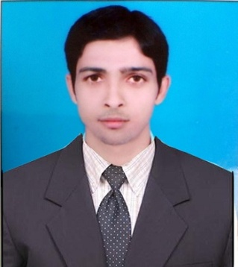
CURICULLAM -VITAE

MUNNA KUMAR GUPTA

Mob: +91 9066698134,

+91 9693550660.

E-mail : munnakumarg94@gmail.com

Objective:

To contribute in challenging environment with my skills capabilities to help Achieve the company’s goals, objectives, Production development and Quality .

Skill Summery:
- Professionally qualified and technically accomplished professional in quality management & Production.
- Ability to learn new technology fast and interest in working out new and innovative methods.
- Effective communicator with excellent planning, organisational and problem solving skills.
PRESENT ORGANISATION:

ESSEL ENTERPRICES PVT Ltd
Location :- 23, Ogalewadi Industrial Estate, Karad,( Maharashtra) Pin Code : 415110
Duration :- JUNE 2016 to JUNE 2017
Designation :- TRAINEE ENGINEER

Key Responsibilities:

- Handle the manpower and shift arrangement.
- Managing Moulding Operation.
- Break down, Preventive Maintenance, Mould Change .
- Maintaining 5S.
- Process parameter setting.
- Organizing mould loading/unloading activities,
- Any other job allotted by management from time to time.

Area of Interest
PROCESSING

- Skill development training for production and quality control.
- Specialization: Injection moulding. Extusion process. Blow molding. Thermoforming process. Compression molding. Blow film
- Machine Handling:-JSW. ENGEL. SUMO. TEXAIR. SP180. SP130.
- Testing :- VST, HDT, MFI, UTM

Machinery Handled :- MILACRONE SERVO 275 TON, ENGEL 80T, SUMO 180T, JIT 180T, JSW 120T, Hopper drier (hot air drier) , vacuum loader, Hot Runner Controller (HRC) .

Raw Material Processing:- PP, Nylon different grades.

Technical Qualifications:

DPT ( Diploma in plastics technology)

Central Institute Of Plastics Engineering & Technology (Cipet, Mysuru) 2013 -2016 :

Qualification | Institute | Board | Percentage  (%) | Year
Diploma in plastics technology(DPT) | CIPET  Mysuru | A.I.C.T.E. | 65 % | Passed  (2013-2016)

Professional Qualification:--

Qualification | School | Board | Percentage | Year
10th | MANGAL SINGH HIGH SCHOOL , RATANPURA | B.S.E.B. | 61.4 % | 2011
12th | GANDHI INTER COLLEGE , GOPALGANJ | B.S.E.B. | 55 % | 2013

Extra activities-
- Microsoft Office; Windows 8.1, 8, 7.
Personal skills:
- Smart Worker.
- Ability to work under pressure and to tight deadlines.
- Organised with good attention to detail.
- A positive can do – will do attitude

Personal Information:

- Name : MUNNA KUMAR GUPTA
- Father’s Name : MR. SHIVNATH PARSAD GUPTA
- Gender : Male
- Date of Birth : 15th APRIL. 1996
- Language ability : English, Hindi.
- Marital Status : Unmarried
- Nationality : Indian
- Address : Vill.+PO. – SANKHE KHAS,
Dist. - Gopalganj,
Pin Code – 841438, Bihar, India
DECLARATION:

I hereby declare that the above-mentioned information is true to the best of my knowledge.

Date: Yours faithfully

Place: KARAD(SATARA) MUNNA KUMAR GUPTA

