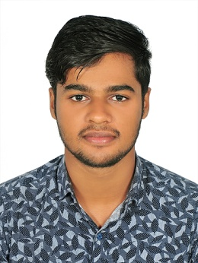  MOHAMMED HISHAM KP  Cell: +91 8089313499  Email:hishamsaaha@gmail.com  Career Snapshot  - B Tech Mechanical Engineering From MEA Engineering College, Perinthalmanna.  - ASNT Level 2 in MPT, RTFI,RT,LPT,UT,VT  Computer Skills  - Solid works basic modeling  - MS Office  - AutoCAD  Strengths  - Strong willpower  - Self-motivated  - Good leadership Quality  - Determined & committed towards responsibilities  - Quick learner and good team player  - Good verbal & communication skills  Hobbies  - Reading  - Cooking  - Travelling  - Workout  Languages Known  - English  - Hindi  - Malayalam  - Tamil  - Urdu  - Arabic  Personal Information  Name: MOHAMMED HISHAM KP  Gender: Male  Nationality: Indian  D.O.B: 22/09/1996  Marital status : Single  Father’s Name: HAMZA KP  Mother’s Name: RAMLA N  Permanent Address:  KARINGAPPARA HOUSE  VETTICHIRA  PUNNATHALA PO  MALAPPURAM  KERALA-676552 |  | OBJECTIVE  To obtain a responsible and challenging position where my educational knowledge and engineering skills will have a valuable application to support and enhance cooperation of the company.
INDUSTRIAL TRAINING

- Undergone Practical training in RT, UT, PT and MPT from UNITED NDT TRAINING AND INSPECTION CENTRE PALARIVATTOM KOCHIN
- Practical Training in PHASED ARRAY from KELTRON.
- Internship in EMMU FOOD PRODUCTS ,KANNOOR

EDUCATIONAL QUALIFICATION
DEGREE/ QUALIFICATION | YEAR OF PASSING | SCHOOL / INSTITUTE | BOARD / UNIVERSITY | PERCE-  NTAGE
B TECH  (Mechanical Engineering) | 2019 | MEA Engineering college, Perinthalmanna | APJ Abdul Kalam Technological university | 73%
CLASS XII | 2015 | VHSS Valanchery | HSE Kerala | 89%
CLASS X | 2013 | AL HUDA CENTRAL SCHOOL,  kadampuzha | CBSE | 90%

PROJECT WORK

UG Project
- Performance and Emission analysis of Two stroke Petrol Engine With Turbocharger at MEA engineering college Perinthalmanna.

ACADEMIC ACHIEVEMENTS & CO-CURRICULAR ACTIVITIES

- Paper presented at National Conference on Advances In Mathematical and Mechanical Engineering in MEA engineering college Perinthalmanna.

EXTRA CURRICULAR ACTIVITIES.

- ASNT Level 2 in RT , VT , UT, MT, LPT, Film interpretation
- MESA Member

Declaration

I do here by declare that the particulars of information and facts stated herein above are true, correct and complete to the best of my knowledge and belief.

Place :Vettichira
Date : Mohammed Hisham KP

